User Manual

*By*

Team - Digital Fortress

TEAM MEMBERS:

Rangeet Pan

Krishna Priya Peddi

Nikhita Singh Satish

Justin K Augustine

Naveen Milind Chalawadi

**System description:**

In this project, we have designed a Pattern Matching Game which involves player authentication using ROM, a variable timer, Random sequence generators and scoring system displayed on the LCD and we have synthesized and tested it using a DE2 board.

The main objective of the game is to is to make certain pattern by input toggle switches such that the combination of randomly generated sequence (2) and the input produces the required pattern.

The game has two modes, 1-Player mode and 2-Player mode. The description of each mode is as seen below,

1. 1-Player Mode: In 1-player mode, the main objective of the game is to score points. The maximum score that a player can achieve is 20. The game has 7-bit input which the player provides by using 7 toggle switches. The player must match the target sequence with the given sequence by providing the input using these toggle switches. With each toggle switch input the player can control its respective segment on the 7-segement display.

The game uses a variable timer. As the player’s score increases the variable timer will increase the game’s pace. For every pulse of the variable timer, the display of the pattern shifts from right-most 7-segment display to the left. This continues for every pulse of the timer. The player must match the target sequence with given sequence before the pattern reaches the end (i.e., left-most 7-segment display). If player matches the sequence, a new random target sequence and input sequence will be generated and player will be awarded with a point. If the player fails to match the sequence till it reaches the end, then the last 7-segment display will be blocked. Starting from the left to right, 7-segement displays will be blocked if the player fails to match the sequence in time. If all the displays are blocked or if the player reaches the maximum score of 20, the game ends.

The game timer will increase the game’s pace for each level. The game level increases as the player scores more points.

1. 2-Player Mode: In 2-player mode, the players compete against each other to win. The maximum score that each player can achieve is 20. The game has 7-bit input for each player. The players provide input by using 7 toggle switches. The players must match the target sequence with the given sequence by providing the input using these toggle switches. With each toggle switch input the player can control its respective segment on the 7-segement display.

Due to shortage of 7-SEG display on the DE2-115 board, we have reused the 7-segment displays like,

Display 1- 1st 7-SEG

Display 2- 2nd 7-SEG

Display 3- 3rd 7-SEG

Display 4- 1st 7-SEG

Display 5- 2nd 7-SEG

Display 6- 3rd 7-SEG

Display 7- 1st 7-SEG

The game uses a variable timer. As the player’s score increases the variable timer will increase the game’s pace. For every pulse of the variable timer, the display of the pattern shifts from right-most 7-segment display to the left. This continues for every pulse of the timer. The player must match the target sequence with given sequence before the pattern reaches the end (i.e., left-most 7-segment display). If player matches the sequence, a new random target sequence and input sequence will be generated and player will be awarded with a point. If the player fails to match the sequence till it reaches the end, then the last 7-segment display will be blocked. Starting from the left to right, 7-segement displays will be blocked if the player fails to match the sequence in time. If all the displays are blocked or if the player reaches the maximum score of 20, the game ends.

The game timer will increase the game’s pace for each level. The game level increases as the player scores more points. After the game ends, the player that scores the highest points wins the game. A green LED respective to the Player, will glow indicating the winner of the game.

1-Player Mode inputs:

LCD displays the score

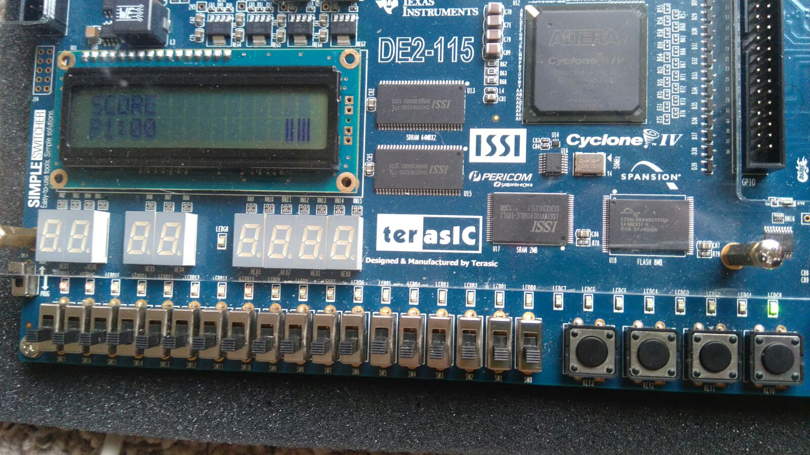

Given sequence

Player1 loads his user ID and pwd by pressing Key 3

Key0 is used as reset

Key1 is used to select the mode

Toggle switches to enter user ID and pwd

Target sequence

Player 1 toggle switches

2-Player mode inputs:

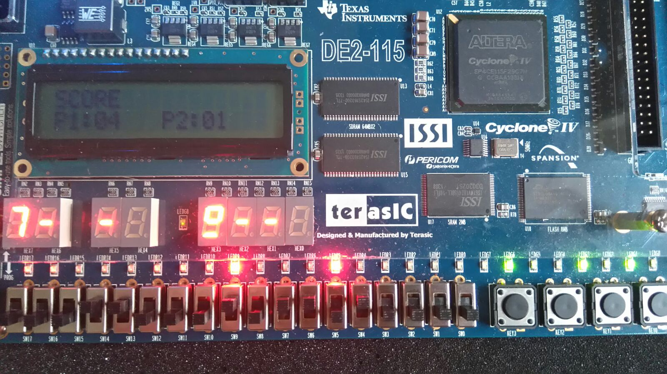

P1 Input

Players loads their user ID and pwd by pressing Key 3

P2 Target sequence

P1 Target sequence

Winner P1

Mode 1

P1 Authenticate

P2 Authenticate

Player 2 toggle switches

Player 1 toggle switches

Toggle switches to enter user ID and pwd

Key0 is used as reset

P2 Input

LCD displays the score

Key1 is used to select the mode

Authentication done notification

**How to play the game?**

1. Switch on the board and keep it in run mode and ensure that all the toggle switches are in pulled down or in logic low state. The board will display something similar to as below:

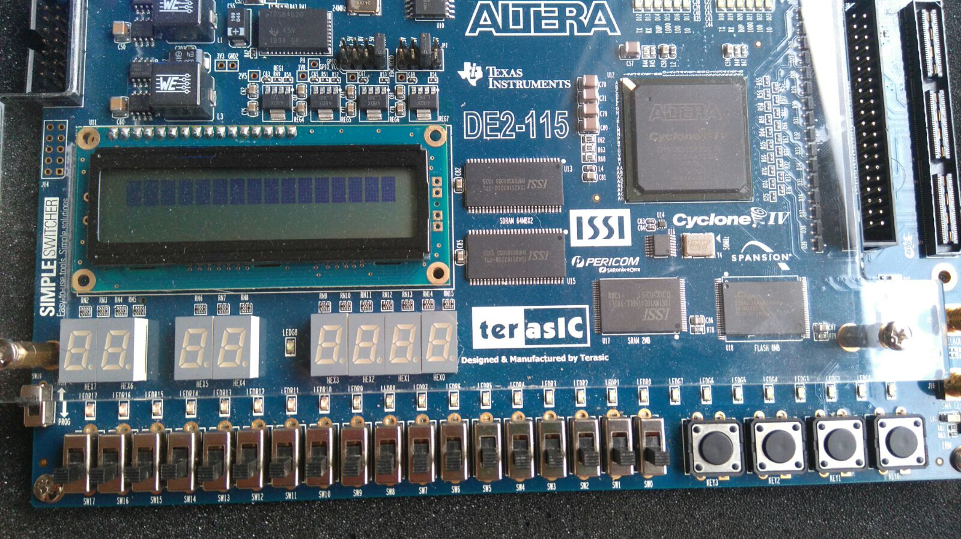

1. The player selects the game mode by using the push button Key1. If the player pushes the button once, then 1-Player mode will be selected and the right most LED will be on to notify the user that 1-Player mode is selected. If player push the button twice, then 2-Player mode will be selected and the right most LED will be on to notify the user that 2-Player mode is selected.



P1 Mode

1. Once the game mode is selected, it’s time to get authenticated. The authentication process will be done using the 4 right most toggle switch (SW0-SW3) and push button Key3. The Player/s must provide their user-id and password to play the game. For both user-id and password, user provide the input using the toggle switches and push the button (one digit/character at a time). If the user-id is verified, then the internal ID of the Player is displayed using red LED(s). For 2-player mode, both of the player needs to be authenticated before starting the game. The Players enter UserID and Password one after the other i.e, first Player A will enter UserID and Password then Player B will do it. The game starts, when both the Players pass authentication.

The Internal IDs of both the players will be displayed using Red LEDs.

The following image shows the display of Internal ID for 1-player mode and 2-player mode respectively.

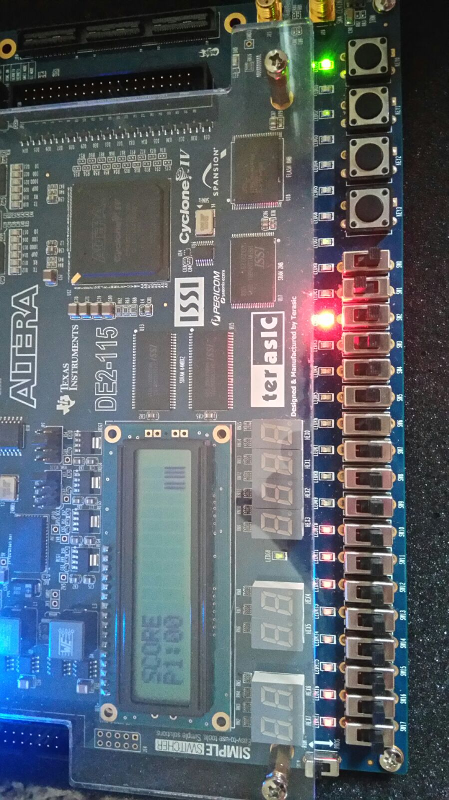

Player 1 toggle switches

1 player Mode

Internal ID of the Player

The following image depicts the scenario when the game starts for 1-player mode and 2-player mode respectively.

1- Player mode:

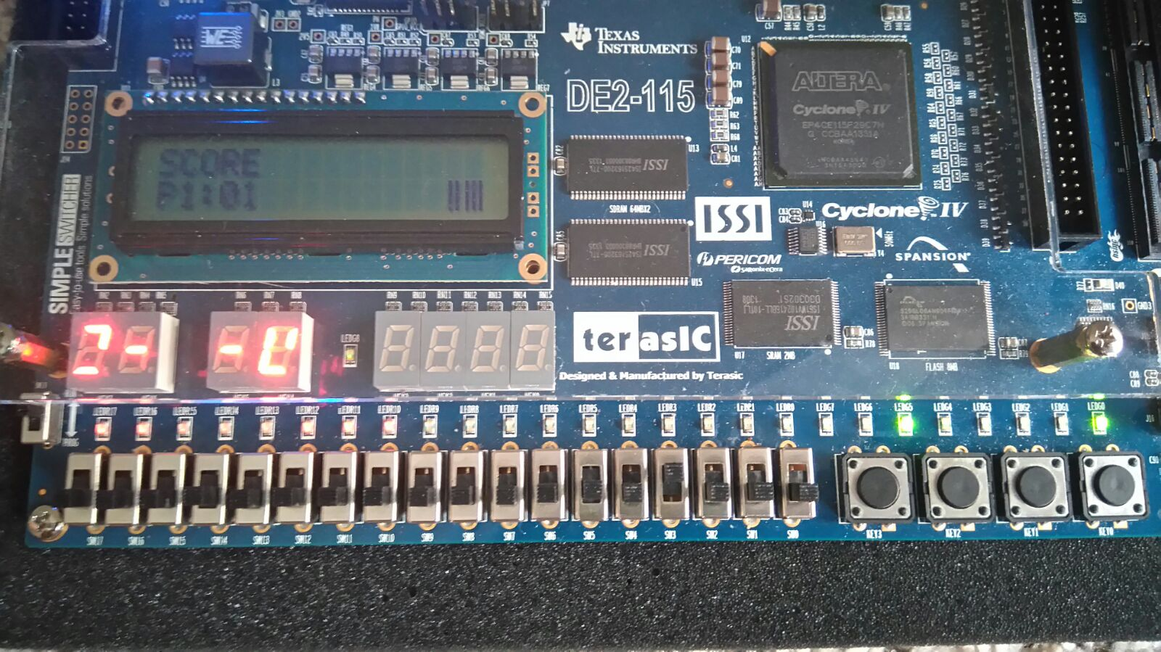

Player’s toggle switches

One player mode

Password verified

2-Player game:

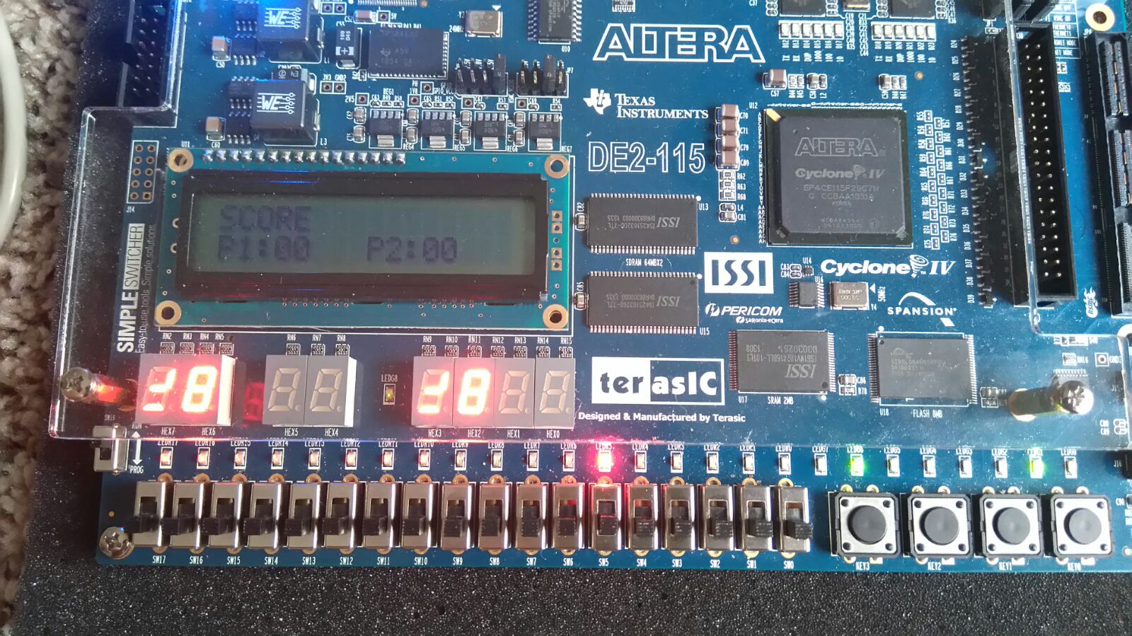

If the user provides wrong credentials three time, s/he can play the game in the guest mode.

1. Once the game starts it will look differently based on the mode selected.

**1-Player Mode:**

1. In this mode, a random sequence input will be generated at the right most 7-SEG display which is called input sequence. Another random sequence will be generated at the left most 7-SEG display which is the Target sequence. The figure below gives the scenario.

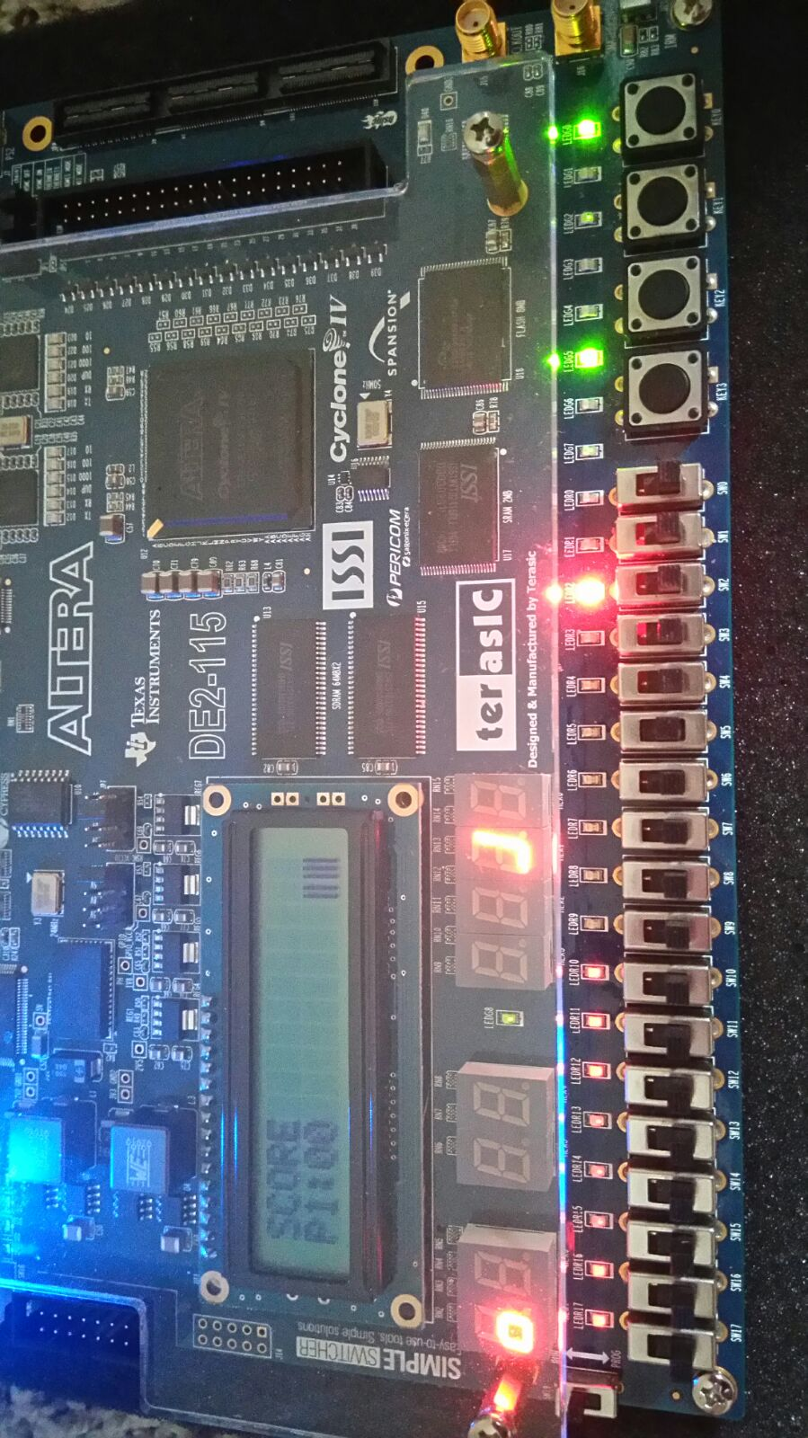

Player’s toggle switches

Password verified

One player mode

Internal ID for Player (100)

Input sequence

Target sequence

1. Now with every clock cycle the input sequence will move to the next display on the left side of the previous display. The figure below gives the scenario.

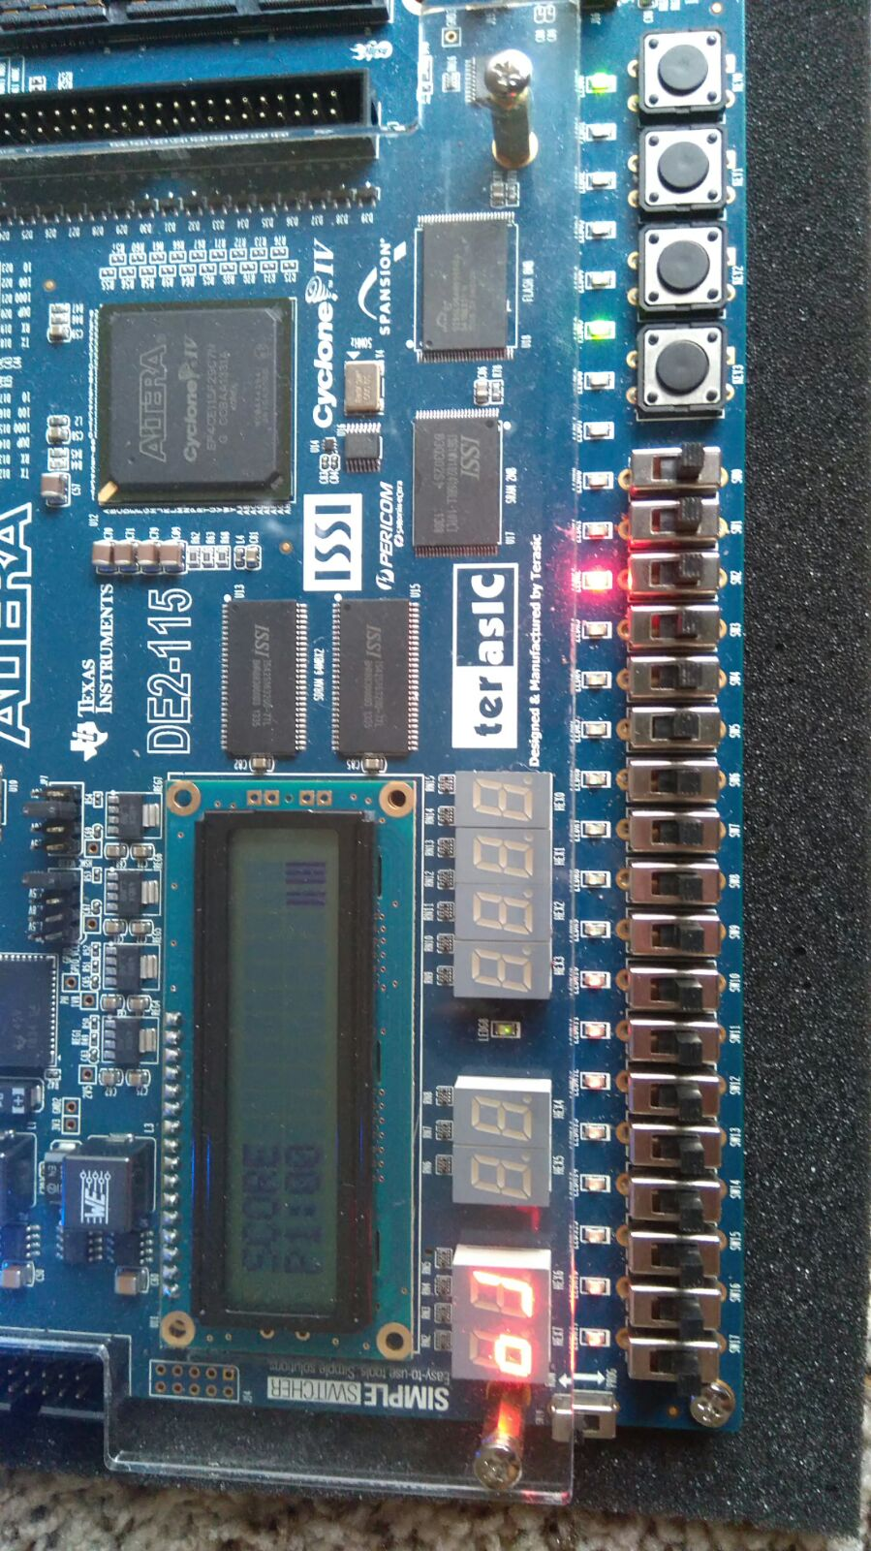

1. The user must provide the input from the seven toggle switches. Every input is mapped with the one segment of the 7-SEG display.

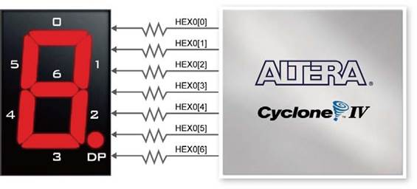

The segment 0 is at the SW17 and the segment 6 is at the SW11.

1. The player has to match the target before it reaches 7-SEG display Hex6. Once it reaches Hex6 and the player didn’t match the sequence, that display will be blocked by showing “-“ in that display. In the future player has to match the sequence before Hex5 because Hex6 is blocked. This will continue till all the 7-segment displays are blocked. The block state looks like the following the picture.



1. Now, when player matches the pattern, a new pattern will be generated and score will be updated.

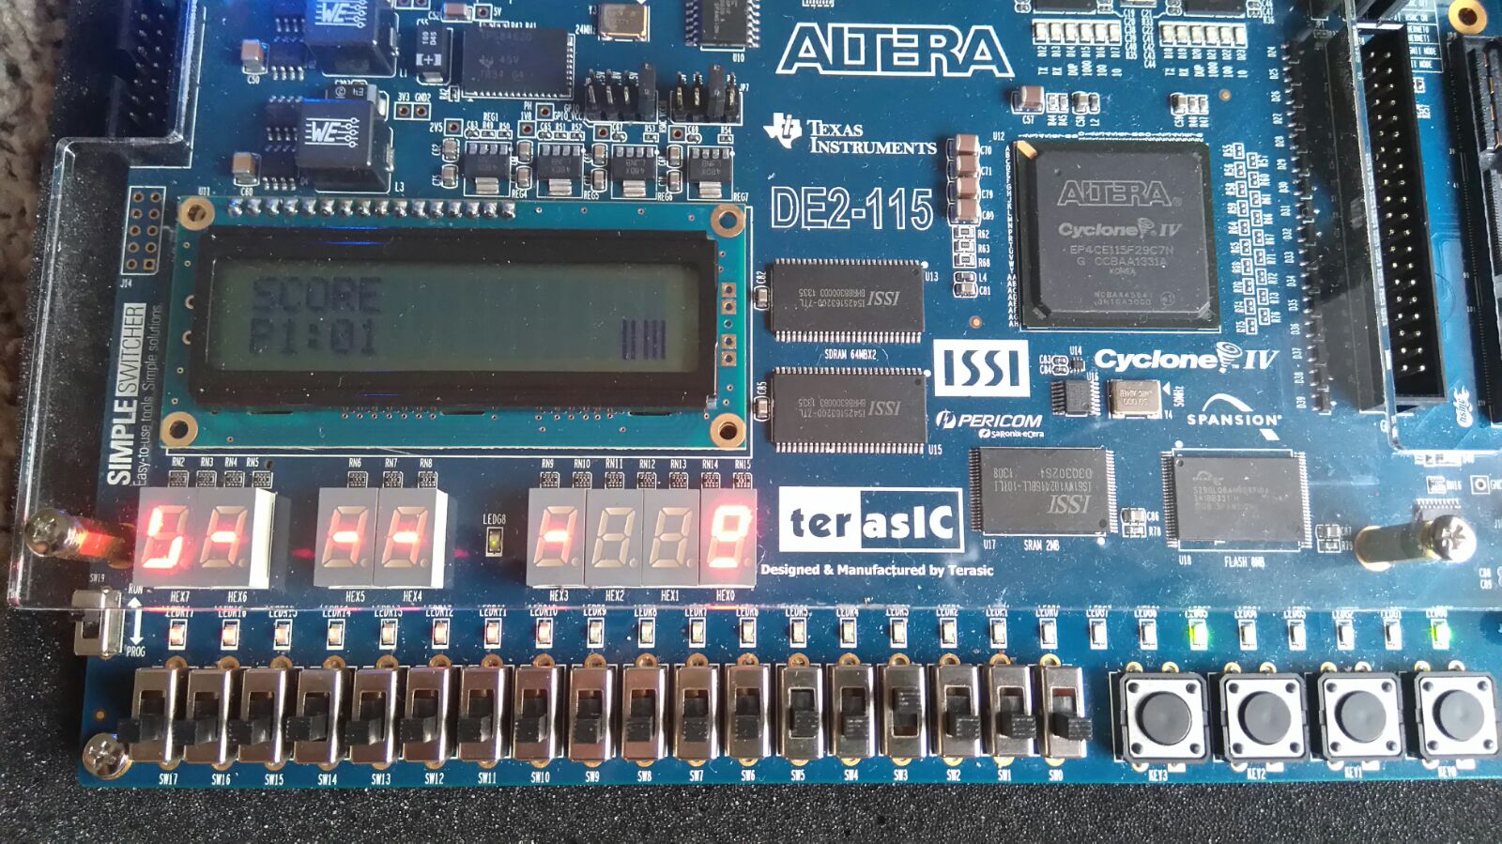

1. Once the score reaches 5 then the game will be faster. With every 5 score, the game will increase its pace.
2. When all the displays are blocked or the player reaches the score 20, the game will end and an LED will indicate the end of game.

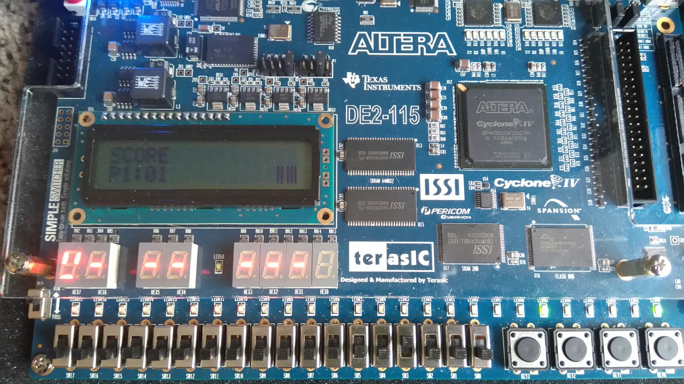

Blocked 7-segment

**2-Player Mode:**

1. In this mode, a random sequence will be generated at the 4th and 0th 7-SEG display. Another random sequence will be generated on (Hex3) which is called target sequence for player 2 and at the leftmost 7-SEG display (Hex7) which is called target sequence for player 1.



P1 Input

P2 Input

P2 Target sequence

P1 Target sequence

1. Now with pulse of the variable timer, the input sequence will move to the next display on the left side of the previous display.

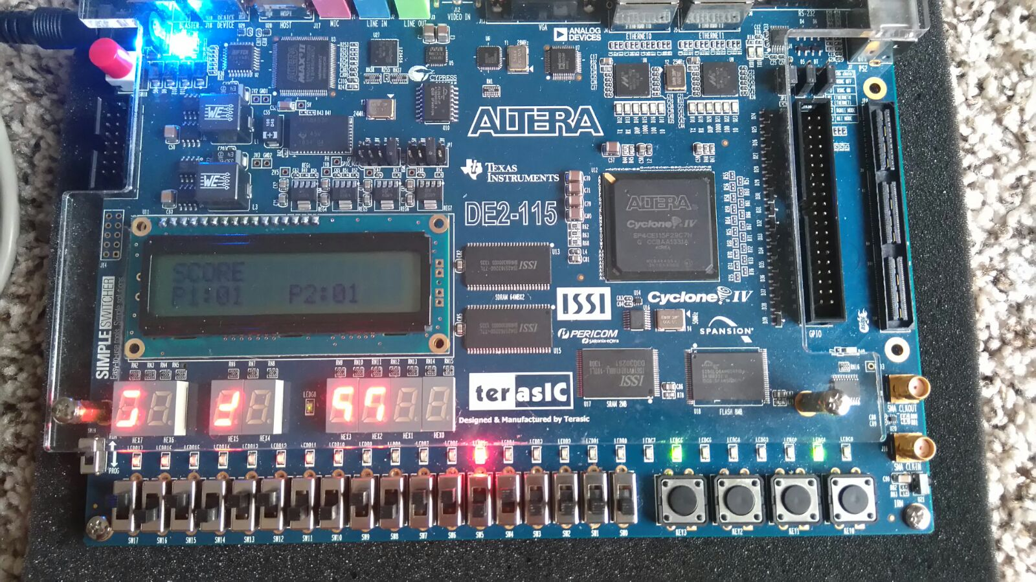

1st the pattern is here

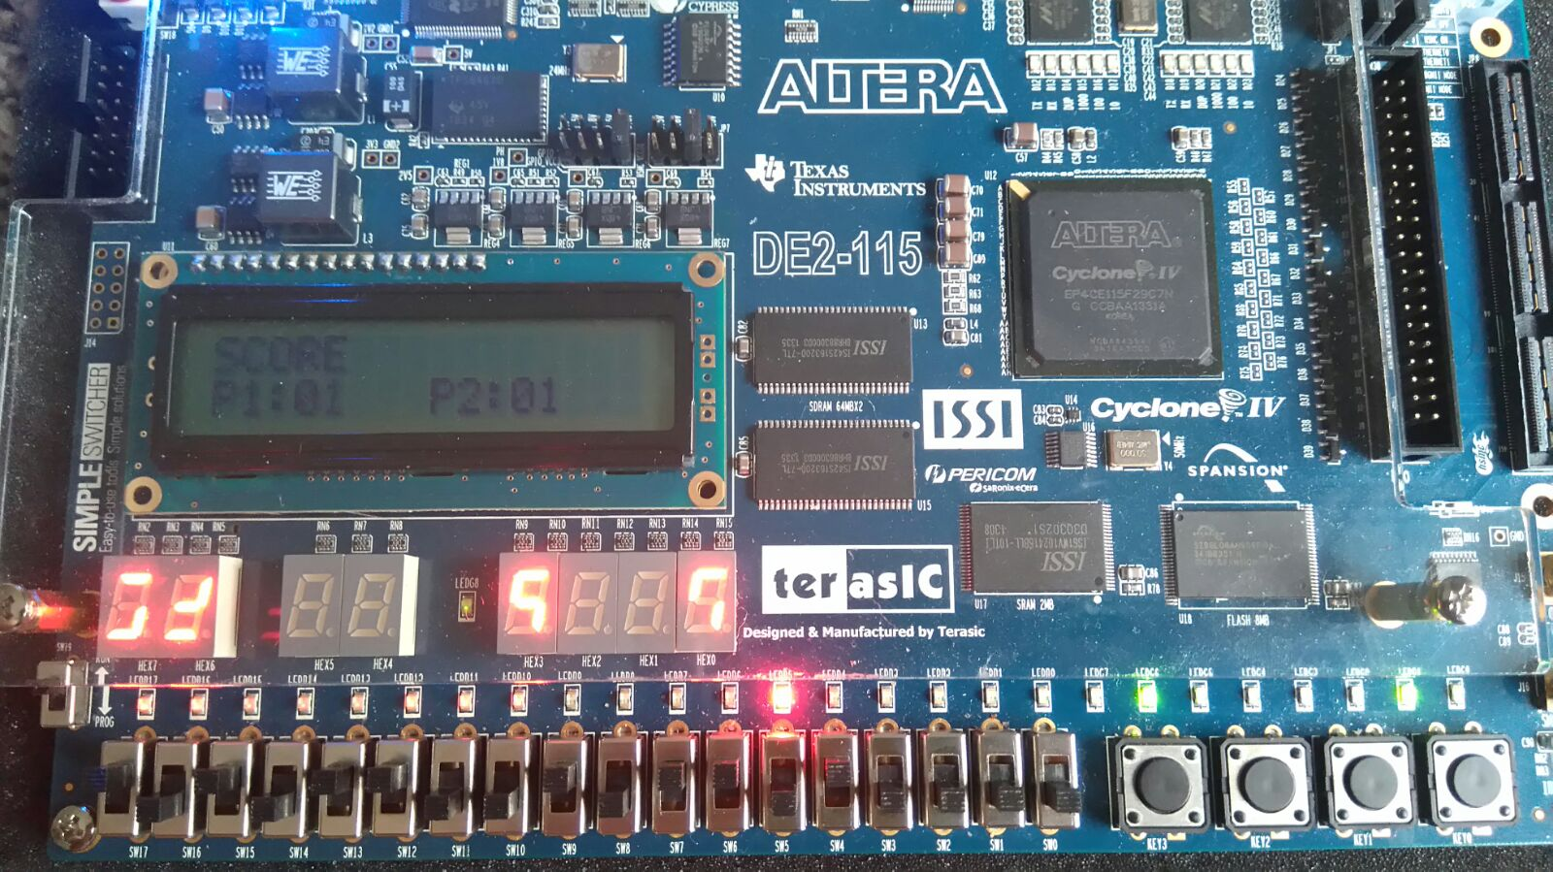

Now it is here

1. The user has to provide the input from the seven toggle switches. Every input is mapped with each segment of the 7-SEG display.



The segment 0 is at the SW17 and the segment 6 is at the SW11.



1. The display for Player1 will be from Hex4-Hex 6 and for Player 2 it will be from Hex0-Hex2. Due to shortage of 7-segment displays, we made three rotations of input sequence over the same 7 segment displays before blocking them. I.e., when the display moves to Hex 2 for Player2 and Hex 6 for Player 1, it will again come back to the Hex 0 and Hex4 display respectively.



1. The players have to match the target before it reaches last 7-SEG display. Once it reaches last display and the player failed to match the sequence, that display will be blocked by showing “-“ in that display. This will continue till all the 7-segment displays are blocked. The following figure gives the scenario.



End of game

Blocked 7-segment

Blocked 7-segment

2 player mode

Allow

P1 wins

1. Now, when player matches the pattern, a new pattern will be generated and score will be updated.



End game LOW

Allow

2 player mode

P1 internal ID

P2 internal ID

Player 2 toggle switches

Player 1 toggle switches

1. Once the score reaches 5 then the game will be faster. With every 5 score, the game will increase its pace.
2. When all the displays are blocked for both the players or any of the players reaches the score 20, the game will end an LED will indicate end of game. The winner will be decided based on the higher score. Here in the two Player mode, Player A scores higher than Player B. Therefore it declares A as the winner by glowing the LEDG3.



Player 1 toggle switches

Player 2 toggle switches

P2 internal ID

End game

P1 internal ID

Allow

2 player mode

Pl A wins

1. This is the case when Player B scores higher than Player A. In this case the end of the game signal is HIGH indicated by LEDR9 and since the score of B is 2> score of A which is 0; thereby LEDG4 glows indicating Player B as winner.

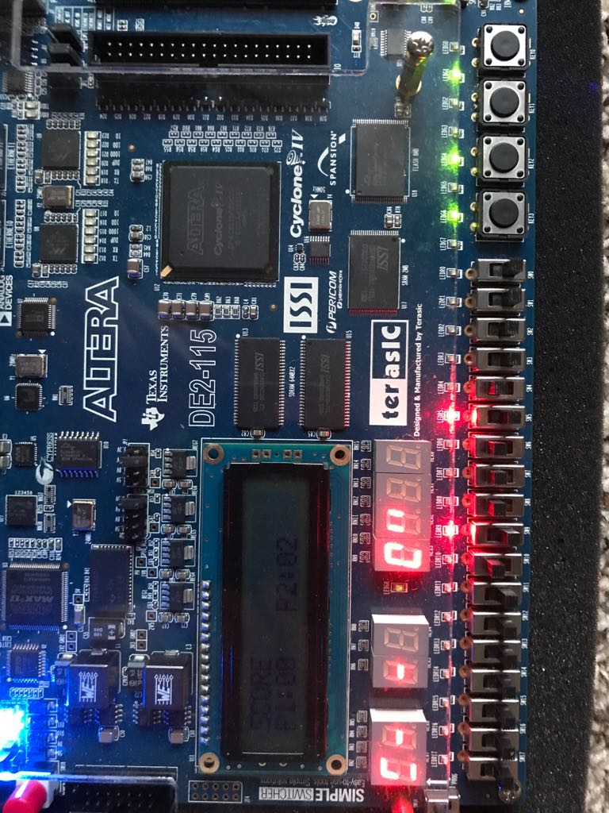

Player 1 toggle switches

Player 2 toggle switches

End game

Allow

2 player mode

Pl B wonwins

1. In the two player mode, when both the players have the same score by the end of the game, then both led’s LEDG3 and LEDG4 glows indicating that both the players have won when End of game LEDR9 has gone HIGH .

Draw game:

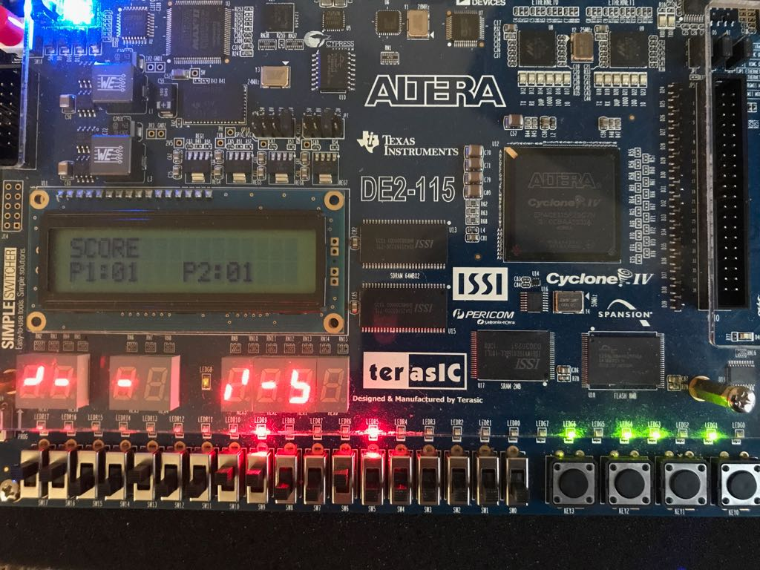

Player 2 toggle switches

Player 1 toggle switches

Pl A won

2 player mode

Pl B wonwins

Allow

End game